CS4187 Computer Vision and Interactivity

Homework Assignment #1

WANG Yinuo 55670000

**INTRODUCTION**

**After learning about computer vision for a period of time, this assignment is to ask us to use the OpenCv Framework to carry out basic operations on pictures and capture image from a webcam.**

**The first task is to** merge the following two images to overlay the running man on the road background.

Figure 2 background

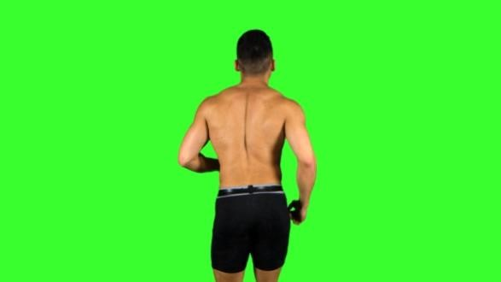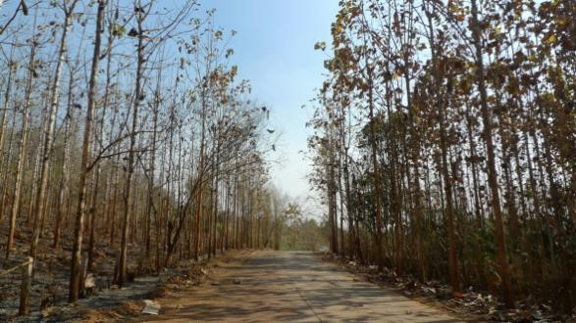

Figure 1 running man

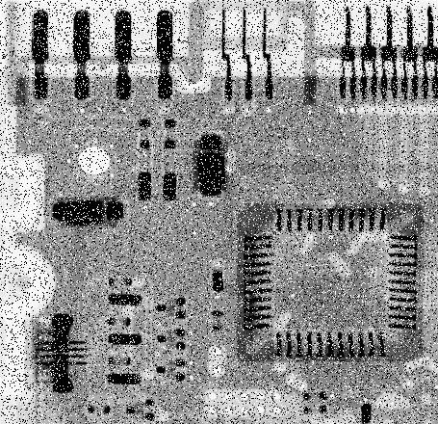The second task is to apply the Box filter, the Gaussian filter, and the Media filter, with different parameters (i.e., sizes of kernel: 3, 5, 7, 9, 11, variant in the Gaussian function: 4, 5, 6, 7, 8, 9, 10), to reduce the noise in the following two images, and report the results.

Figure 4 Circuit

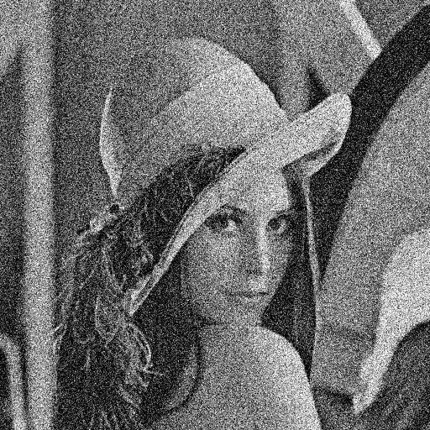

Figure 3 Lena

The last task is to capture the real-time grayscale image stream in grayscale from a webcam and plot the histogram of each frame in real time. In addition, we should add a mouse-click interaction, so that when the user click on the webcam image, the color of the pixel at the clicked position and all the other pixels with the same color/intensity value as the clicked pixel will be inverted.

**RELATED WORK**

1. OpenCV Framework and c++ learning

2. Basic knowledge of image processing

3. Basic knowledge of image filtering

**APPROACH**

1. Merge two image

Since the background of the man's picture is green, I just need to determine whether the pixels in the image are green, and if so, I just replace it with the pixels of the background image.

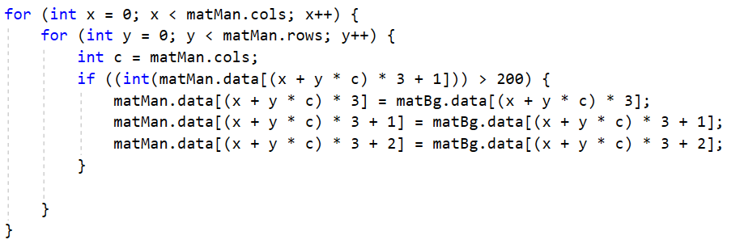The main code is as follows

Figure 5 main code of task 1

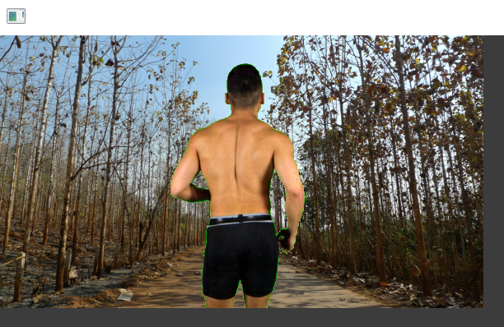And the results are represented in fig.6 below.

Figure 6 result of task 1

To complete task 2, I applied different filtering functions and different kernel sizes.

Here are some examples of main Code.

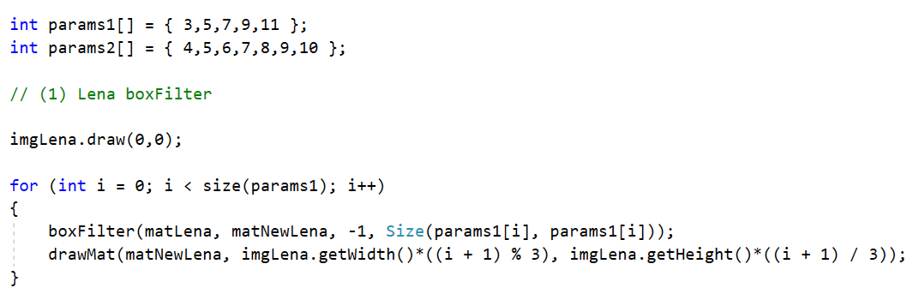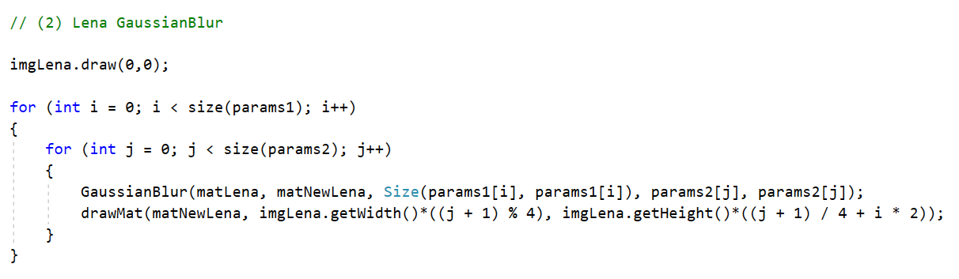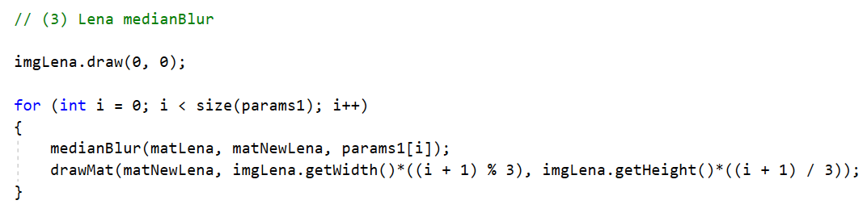

I will draw the original image first and then show the filtered image with different parameter values. The results are represented in figures below.

Box filter with different parameters for Lena: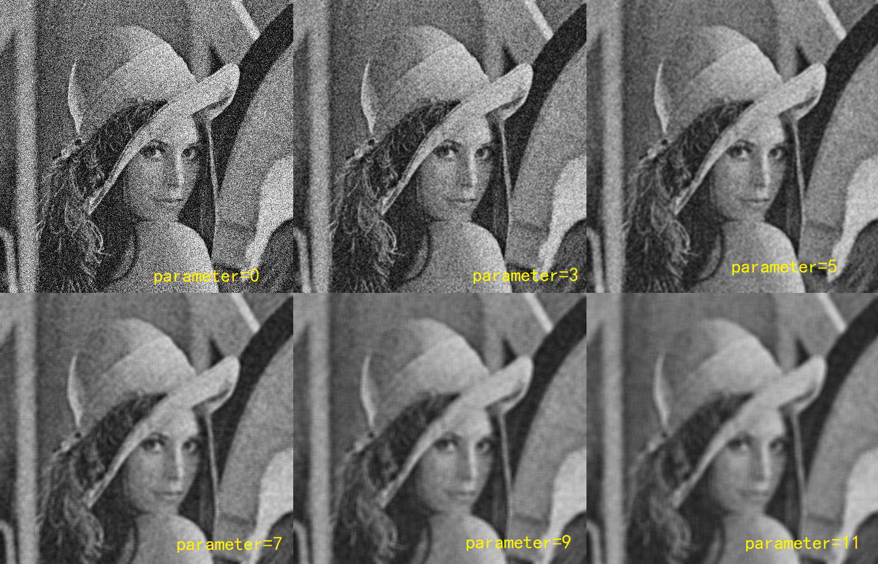

Box filter with different parameters for Circuit: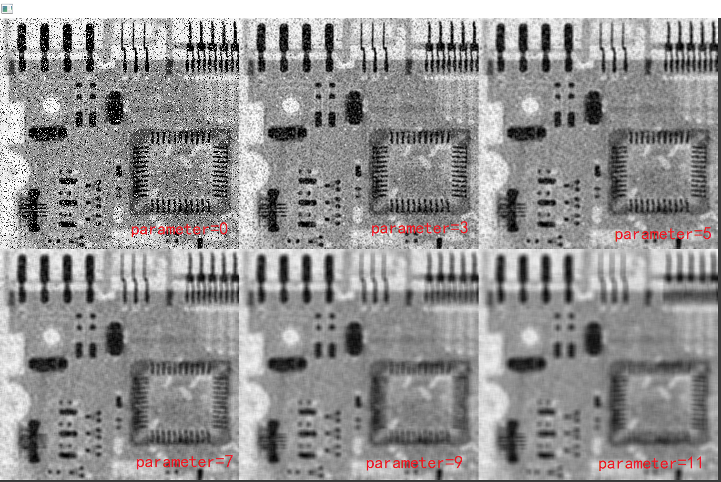

Gaussian filter with different parameters for Lena(Since there are too many parameters, I only take the kernel size as (3,3) here. Refer to the code for the full images version.): 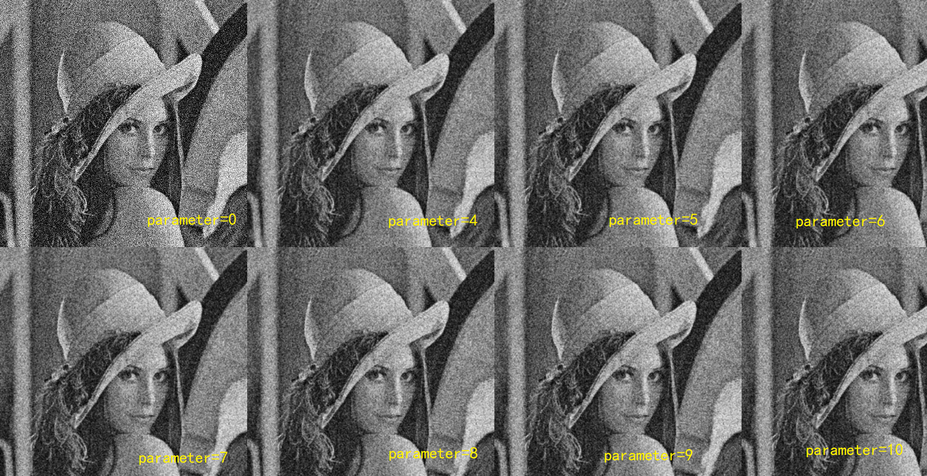

Gaussian filter with different parameters for Circuit(kernel size is (3,3), too): 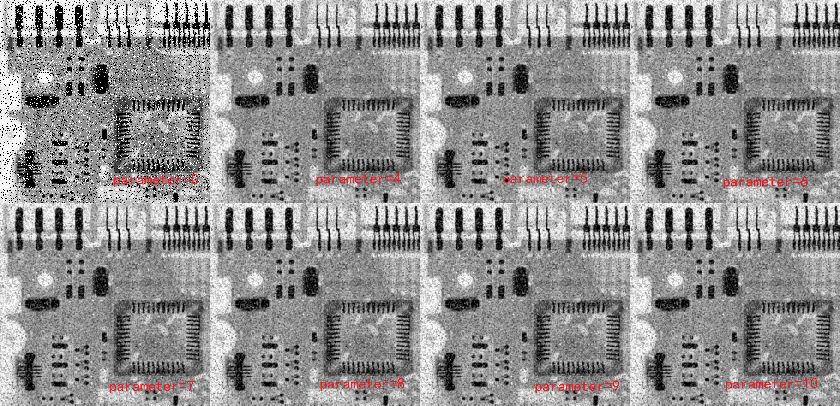

Median filter with different parameters for Lena: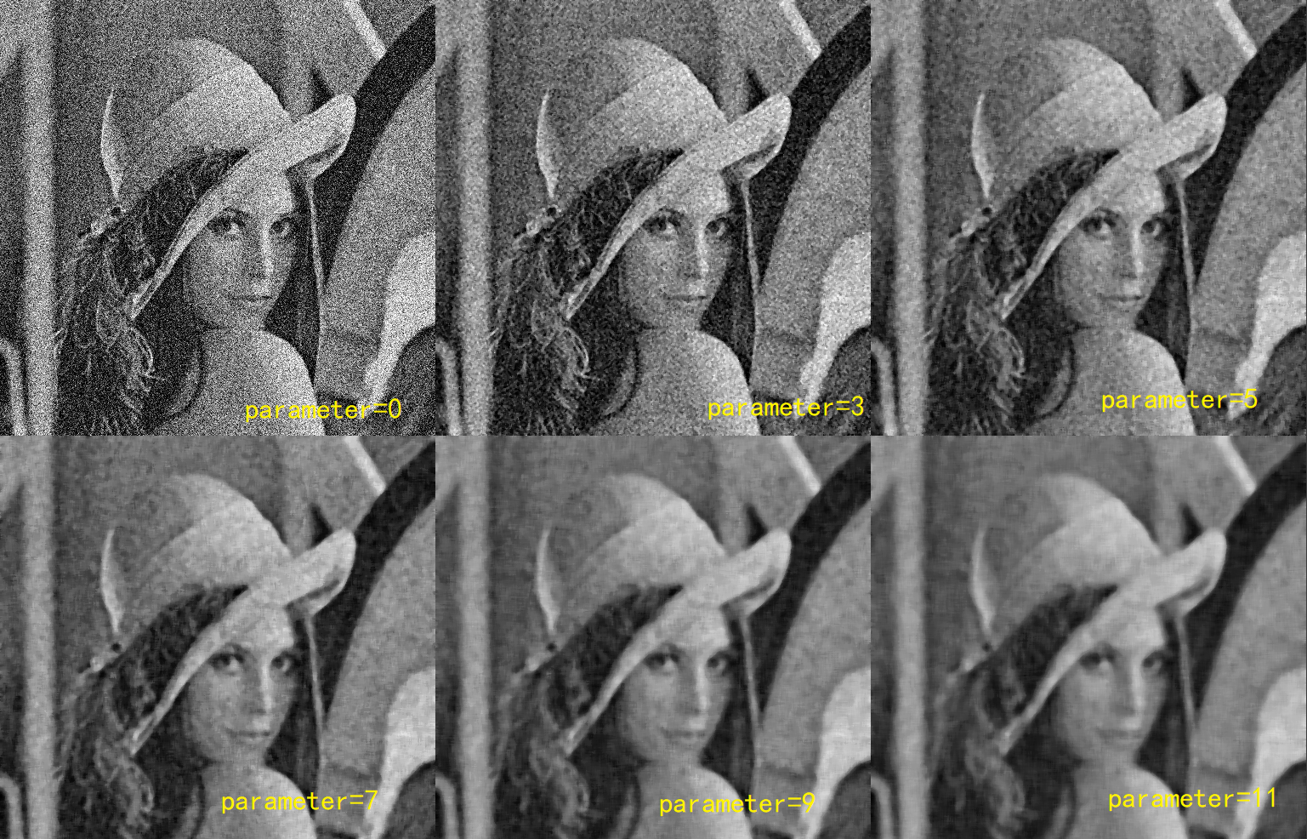

Median filter with different parameters for Circuit: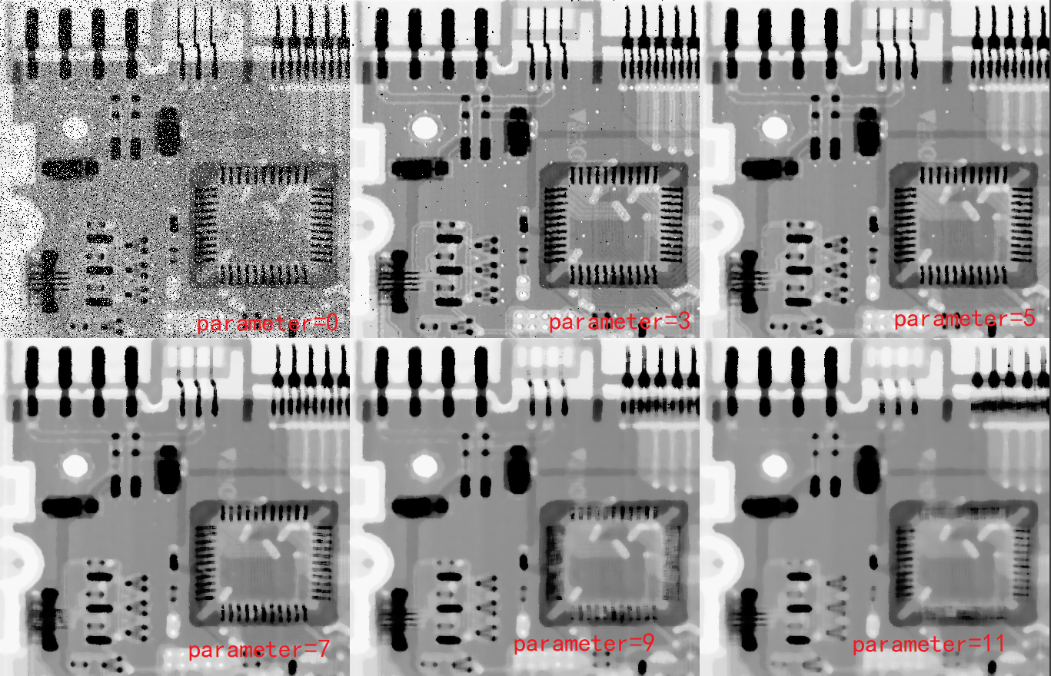

From these images and the knowledge of image filtering we can see, for Lena, the Gaussian filtering is the best. Because this image is obviously accompanied by Gaussian Noise, it is better to use linear filtering. Gaussian filtering and box filtering both are linear filtering but Gaussian filtering can preserve the edge effect better than other filters with the weights chosen according to the shape of a Gaussian function. So we choose Gaussian filtering.

However, for Circuit, Media filter is the best. Because this image is with Salt-and-Pepper Noise while Median filter which is a non-linear filtering is very effective in removing this noise. In this case, box filtering will make the image blurred, while Gaussian filtering has poor denoising ability. So we choose Median filter.

In task 3, we should capture the real-time grayscale image stream in grayscale from a webcam and lot the histogram of each frame.

The main code is as follows:

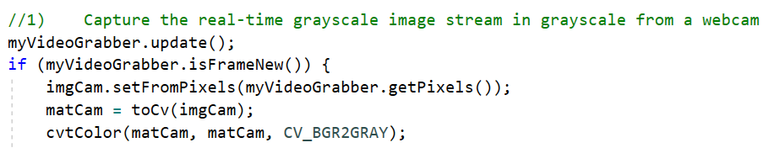

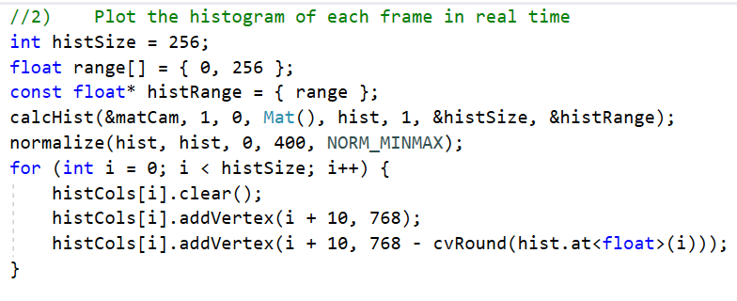

The results are shown below:

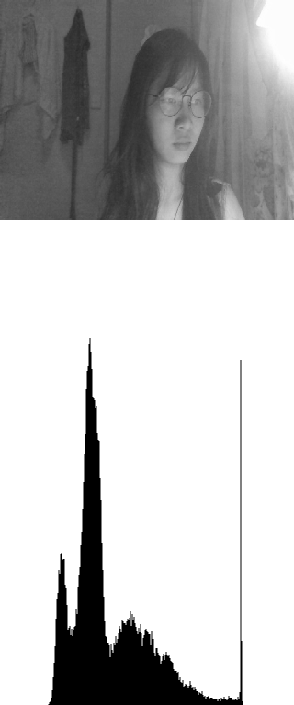

In this task, we also need to interact with the mouse. When the mouse is pressed on a certain pixel, all pixels of the same color as the pixel must be reversed.

For example, if the white pixel is clicked, all white parts in the picture will turn black.

Just as shown below.

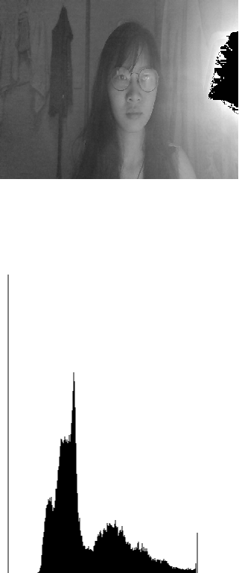

The logic of code is that if the mouse clicks on a pixel in the frame, the ‘isClick’ flag will be set to true, then ‘intensity’ stores the pixel's color, and in the update function reverses the color for all pixels that have the same color as the pixel.

